General Description – Ionpure Electrodeionization System

Final polishing is performed through the use of a continuous electrodeionization (CEDI) system. At the heart of this system is IONPURE LX-Z module - an advancement on conventional ion exchange technology in which the ion exchange resins are continuously regenerated through the use of an imposed electric current making the process chemical-free. Since commercial inception in 1987, this technology has been widely accepted in many markets such as the pharmaceutical, power, microelectronics and food/beverage industries.

The Ionpure Process
Continuous Electrodeionization (CEDI) is the process of removing ionized or ionizable substances from water using ion exchange membranes, electrically active media (typically ion exchange resin), and a DC electric potential. Continuous demineralization in the Ionpure module consists of three coupled processes:

- Feed – Water is feed through a series of alternating dilute and concentrate compartments with electrode compartments at either end. The feed water (RO permeate) to be deionized is fed through the dilute feed compartments with a fraction of the flow being diverted to the concentrate and electrode feed (internal) compartments. The ion exchange resin accepts the ions in the feed water just as in conventional ion exchange, subject to the usual mass transfer and thermodynamic equilibrium considerations.
- Removal – In CEDI, the ion exchange resin serves as a bridge for the cations and anions to travel rather than the conventional method of ion exchange where they are ionically bound and require chemical to be removed. Electrodes at the end of each Ionpure module produce a DC electrical field which cause the ions to migrate toward ion selective membrane (AEM and CEM) through to the adjacent concentrate compartments. Once in the concentrating compartment, the ions are carried away by the concentrate flow. This process is particular to electrodeionization. The reject stream is sent to drain or in some cases is recycled back into the process.
- Regeneration – As the water become more and more pure further down into the dilute compartment, the electric potential also causes some of the water present to split into hydrogen and hydroxyl ions which regenerate the ion exchange resins continuously in-situ, without the addition of chemical reagents. This process is particular to electrodeionization and can proceed even in the absence of ions in the feed water. The result is an LX module that continually regenerates itself during operation.
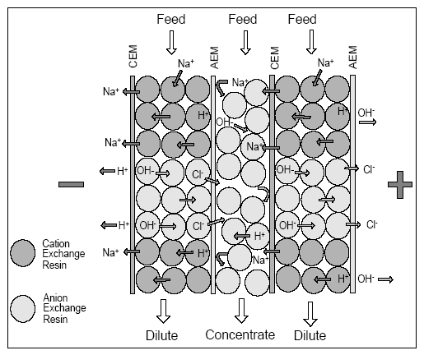

As the truly the only chemical-free method of producing high purity deionized water, the benefits of using electrodeionization are:

- Continuous operation, no downtime for regenerations
- Only true chemical-free process, no brine injection required
- One pass operation, no need for concentrate recirculation
- Guaranteed leak free
- Proven technology with 1000’s of systems installed worldwide

LX-Z Module Specifications
Design Product Flow
LX04Z | 2.0 gpm (0.44m3/h)
LX10Z | 5.0 gpm (1.1 m3/h)
LX18Z | 9.0 gpm (2.0 m3/h)
LX24Z | 12.5 gpm (2.8 m3/h)
LX30Z | 15 gpm (3.3 m3/h)
Number of Modules | 1
Manufacturer | Evoqua Water Technologies
Country of Origin | United States of America
Model | LX-Z
Endplate Material | Machined aluminum
Cell Spacer Material | PVC
Pressure Rating | 100 PSIG (7 bar)
Operating Temperature Rating | 113º F (45C)
Dilute In/Product Process Connections | 1 ¼” BSP Male w/ O-Ring seals
Concentrate In/Reject Process Connections | ¾” BSP Male w/ O-Ring seals

Operating Parameters*
Maximum Feed Temperature | 113°F (45°C)
Minimum Feed Temperature | 41°F (5°C)
Maximum Feed Pressure | 100 PSIG (7 bar) (@113°F (45°C) maximum temperature)
Pressure Drop:
@ minimum flow rate | 10-15 psi (0.69-1.03 bar)
@ nominal flow rate | 25-35 psi (1.72-2.41 bar)
@ maximum flow rate | 40-50 psi (2.76-3.45 bar)
*If any of the operating conditions are not within the limits given, consult the Ionpure for application assistance.

Feed Water Requirements*

Parameter:
Feed Water Source | RO Permeate
Feed Water Conductivity Equivalent including CO₂ | < 40 micro S/cm
Silica (SiO₂) | < 1 ppm
Iron, Mn, Sulfite | < 0.01 ppm
Total Chlorine/Chloramine | < 0.02 PPM
Hardness | < 1.0 ppm
Dissolved Organics | < 0.5 ppm
Operating pH range | 4 – 11
Operating Temperature | 41 – 113º F (5 – 45C)
Inlet Pressure | < 100 psi (7 bar)
*If any of the feed water parameters are not within the limits given, consult the Ionpure for application assistance.

